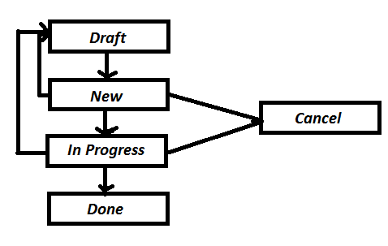
Final examination.
You are required to create and implement the following entities
- Task
- Status
- ItemTags
- Tag

Reference:
User Histories
As a User I want to create a task that will have a title and description and I want to be able to assign it a tag and a status.
As a User, I want to modify information from tasks, like title, description and/* status*/.
The task’s initial status will be Draft and if you update a task, its status should return to Draft.
As a User I want to assign a due date.
The due date must be equal or greater than today.
As a User I want to assign a numeric priority, so I can sort tasks in descending order.
The lowest priority should be 1 and this value will be the default when a task is created
As a User I want to archive a task, so this task will be no longer visible on the list
As a User I want to create tags, tags must be unique.

As a User I want search and sort my tasks by tags, status, title and by a range of dates.
As a User I want to assign a maximum of 10 tags by task.
As a User I want to delete a tag if it was not assigned to a task.
As a User I want to know how many tasks are associated with a tag.

Flow for Status:

Task
- Id
- Title
- Description
- CreateDate
- ModifyDate
- DueDate
- Priority
- StatusId
- IsArchived

Tag
- Id
- Name
- IsGlobal

Status
- Draft
- InProgress
- Cancel
- Done

TaskTags
- TaskId
- TagId

